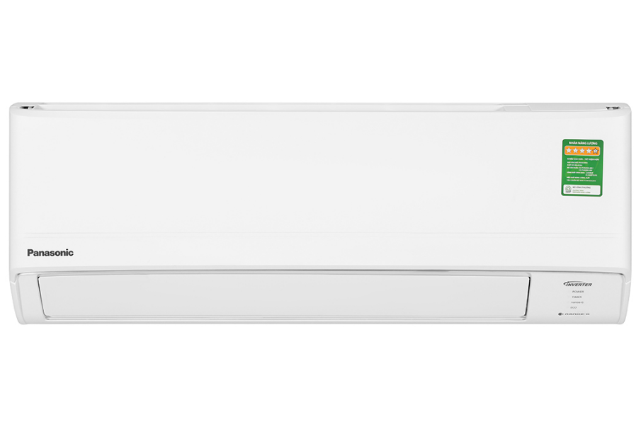

**10.740.000₫**

**Technical specifications of Panasonic Inverter 1 HP CU/CS-PU9ZKH-8M air conditioner**

* Machine Type:

1 way (cooling only) With Inverter

* Cooling capacity:

1 HP - 9,040 BTU

* Effective cooling range:

Under 15m² (from 30 to 45m³)

* Dust filter, antibacterial, deodorant:

Nanoe-G filters PM 2.5 fine dust

* Power saving technology:

ECO integrates AI Inverter

* Rapid cooling:

Powerful

* Utilities:

Night sleep mode Sleep for the elderly and children Dehumidification function Self-diagnosis function BlueFin coating condenser prevents corrosion Super quiet operation Quiet on-off timer Automatically restarts when power is available

* Power consumption:

0.8 kW/h 5 stars (Energy efficiency 4.84)

* Cooler:

Length 77.9 cm - Height 29 cm - Thickness 20.9 cm - Weight 8 kg

* Outdoor:

Length 72.7 cm - Height 51.1 cm - Thickness 26.6 cm - Weight 18 kg

Introducing the company 

- Japanese brand.  
- Established in 1918. Panasonic entered the Vietnamese market very early, in the 1950s.  
- Panasonic is famous for its refrigerators, air conditioners, televisions and household appliances such as microwaves, fans, air conditioners. blender...  
- Panasonic products are famous for their high durability, energy saving, and beautiful designs.

[**Detailed review of Panasonic Inverter 1 HP CU/CS-PU9ZKH-8 air conditioner**](https://www.dienmayxanh.com/kinh-nghiem-hay/danh-gia-chi-tiet-may-lanh-panasonic-inverter-1-hp-1539222)

[***Panasonic Inverter 1 HP CU/CS-PU9ZKH-8 air conditioner***](https://www.dienmayxanh.com/may-lanh/panasonic-inverter-1-hp-cu-cs-pu9zkh-8#2-gia)***can automatically adjust capacity to suit cooling time, to bring optimal electricity savings. Furthermore, the product also has the ability to quickly cool and filter dirt and bacteria up to 99% effectively, meeting user needs and providing better protection.***

**Design**

**Cooler:**

- The indoor unit is simply designed and has a white color scheme, thereby easily coordinating with other furniture in the room.

- The case is made of high quality plastic and has good durability. In particular, the lid of the machine is designed to be removable, making it easy for users to remove and install when cleaning [the air conditioner](https://www.dienmayxanh.com/may-lanh) .

**Outdoor:**

- The outdoor unit has a neat rectangular shape with a shell material **that can withstand temperature, sun, rain and other factors** in the installation environment.

- The radiator is made of **aluminum material** , has good durability, helping to prolong the life of the air conditioner throughout its operating time.

- Gas pipes are made of **pure copper** , capable of fast and stable heat transfer, while also providing high durability during use.

**Refrigeration technology**

- The air conditioner has an operating capacity of **1 HP** , providing maximum cooling efficiency for rooms with an area of **​​less than 15m²** .

- [Powerful fast cooling mode](https://www.dienmayxanh.com/kinh-nghiem-hay/cac-che-do-lam-lanh-nhanh-thuong-gap-tren-may-lanh-837183#powerful-panasonic) : The air conditioner operates at maximum capacity after activating Powerful mode, helping the room temperature to quickly lower to the set temperature, giving a fast cooling speed of up to 18% **.** Compared to conventional air conditioners, users can feel cool air in the shortest possible time.

- **Night Sleep mode** : This [Panasonic 1 HP air conditioner](https://www.dienmayxanh.com/may-lanh-panasonic?g=1-hp) will automatically increase the temperature at night, helping the room temperature not differ too much from the body temperature, thereby **bringing comfort** to the user. when sleeping all night as well as **minimizing pain or cold** when using air conditioning all night.

**Air blowing mechanism**

[This Panasonic Inverter air conditioner](https://https/www.dienmayxanh.com/may-lanh-panasonic?g=may-lanh-inverter) can control the air flaps **up and down automatically,** and left and right need to be adjusted manually. The cold air can thus be pushed throughout the room, giving an even cooling effect.

**Power saving technologies**

- Air conditioners have the ability to effectively save electricity thanks to equipped with Inverter technology.

- [Inverter technology](https://www.dienmayxanh.com/may-lanh?g=may-lanh-inverter) : Controls compressor operation to ensure that a **stable cold temperature is maintained** inside the room, while also **using electricity economically and minimizing the noise** of the air conditioner during operation.

- [AI-integrated ECO mode](https://www.dienmayxanh.com/kinh-nghiem-hay/nhung-cong-nghe-noi-bat-tren-may-lanh-panasonic-1242950#eco-tich-hop-AI) : ECO mode is integrated with AI artificial intelligence technology, allowing the air conditioner to automatically adjust operating capacity in accordance with the time it reaches the set temperature, thereby **brings significant energy savings** while still ensuring comfortable cooling efficiency for users.

- [Panasonic air conditioner](https://www.dienmayxanh.com/may-lanh-panasonic) consumes about [0.8 kW/h](https://www.dienmayxanh.com/kinh-nghiem-hay/cong-suat-tieu-thu-dien-toi-da-855107) of electricity , achieving **5 stars** on the energy label with **an efficiency of 4.84** .

**Air filtration ability - health**

[Nanoe-G technology filters PM 2.5 fine dust](https://www.dienmayxanh.com/kinh-nghiem-hay/bo-loc-nanoe-g-tren-may-lanh-panasonic-804161) : Releases a large number of negative ions - clinging to dust particles suspended in the air (including PM 2.5 fine dust particles), then follows the air current to bring them back. air conditioner air intake pipe. Here, they will be **effectively removed up to 99%** , thereby **returning fresh and dust-free air** to the room, optimally protecting the user's health.

*\*Video is for illustration purposes only*

**Utilities**

- **Dehumidifying function** : Air conditioners have the ability to **slightly dehumidify and help keep the room dry** , creating a comfortable feeling for users on humid days caused by the weather.

- **Self-diagnosis function** : Helps users **identify and fix errors quickly** , so as not to interrupt the use of the air conditioner.

- [Super quiet operation](https://www.dienmayxanh.com/may-lanh-hoat-dong-sieu-em-quiet) : The engine will operate at the lowest speed, and the air conditioner will **blow out a gentle airflow** , helping users **feel cool and comfortable** in a quiet space, suitable for people. People who have difficulty falling asleep like children and the elderly.

- [Automatically restarts when there is power](https://www.dienmayxanh.com/kinh-nghiem-hay/cac-che-do-thuong-thay-tren-may-lanh-795107#tu-khoi-dong) : The air conditioner has the ability to **automatically restart after a sudden power outage** , without the user having to reset the machine's operating mode afterwards.

*In short, the Panasonic Inverter 1 HP CU/CS-PU9ZKH-8 air conditioner has the ability to filter dust and bacteria up to 99% effectively, contributing to better respiratory health protection for users. Not only that, the air conditioner has the ability to cool quickly, operate super smoothly, restart automatically when there is power and dehumidify for user convenience.*